# **CHAPTER 2**

# **REVIEW OF WIND ENERGY CONVERSION (WEC) SYSTEMS**

In previous chapter, background of wind energy conversion systems is introduced and related wind energy statistics are summarized and tabulated. In this chapter, detailed survey of wind energy fundamentals and general overview of wind energy conversion systems will be summarized. To accomplish this, this chapter is divided into five main parts. In the first part, wind power equations and key parameters will be discussed. This data especially used in wind turbine investment calculations and wind potential estimation techniques. Then challenges in wind energy conversion systems will be introduced and common problems will be addressed. In the next part, existing wind turbine technologies will be classified and evaluated according to their mechanical and electrical aspects. Then three main flux orientations in PM based systems will be shown and explained. Finally, the importance of modularity in wind energy conversion systems and the advantages and disadvantages of axial flux PM machines will be evaluated. Also in the last part, reasons for choosing direct drive axial flux permanent magnet generator concept will be explained.

## Power Equations and Parameters

The available shaft power (output power) *P* from a horizontal axis wind turbine can be expressed as a function of the wind speed as follows:

$P=\frac{1}{2}ρ_{air}C_{p}(λ,β)πr^{2}v^{3}$ (2-1)

where , $ρ_{air}$ is the mass density of air , $C_{p}$ is the power coefficient which is a function of the tip speed ratio *λ* and the pitch angle *β*, $r$ is radius of the turbine blade and $v$ is the wind velocity. Power coefficient, sometimes called performance coefficient, can be defined as the ratio between the captured wind power and the available input power of the wind. Therefore, it tells us how efficient the turbine is. Generally imperfections in blade manufacture reduces the actual energy yield of the turbine less than the useable energy. Theoretically, maximum 59% (approximately 16/27) of energy carried by the wind can be extracted by an ideal wind turbine. This result is concluded by German physicist Albert Betz in 1919. This limitation is valid for both vertical and horizontal axis wind turbines. Maximum value of performance coefficient (*Cp*) is limited by Betz criterion. Since physical limitations exist in nature such as friction and other mechanical losses, maximum value of the performance coefficient *Cp* is always lower than theoretical maximum of Betz constant.

In [[1](http://ieeexplore.ieee.org/stamp/stamp.jsp?tp=&arnumber=6226866&isnumber=6331663)] power coefficient is defined as a nonlinear function of TSR (λ) and pitch angle (β)  as follows,

$C_{P}\left(λ,β\right)=C_{1}\left(\frac{C_{2}}{λ_{i}}-C_{3}β-C_{3}\right)e^{\frac{{-C}_{5}}{λ_{i}}}+C_{6}λ$ (2-2)

where,

$\frac{1}{λ_{i}}=\frac{1}{λ+0.08β}-\frac{0.035}{β^{3}+1}$ (2-3)

These coefficients shown above depend on the turbine physical characteristics. Investigation of these values is out of scope of this thesis. Tip speed ratio (TSR) is defined as a ratio of linear tip speed of turbine blade to speed of the wind as shown in (4). This ratio is very useful when designing a wind turbine. Optimal TSR is desired to obtain maximum power from wind as much as possible.

$λ=\frac{Rω_{M}}{v}$ (2-4)

where,  *v* is the wind speed, *wm*  is the rotational rotor speed and *R* is the rotor radius. TSR is a kind of measurement of how fast turbine blades rotate. Until a proper limit, higher rotational speeds leads to higher output power levels. Therefore, high TSR is aimed when designing a wind turbine. Although TSR calculations will not be actively utilized in this thesis work, this topic is very important because of the sizing issues. If turbine blades rotate too slow then incoming air to the turbine is not used efficiently as natural result of Betz limit. If turbine blades rotates too fast, blades act as a solid wall to the turbine and then efficiency decreases again. As mentioned earlier in previous chapter, variable speed horizontal axis wind turbines use pitch control actively in order not to encounter high torque transients by controlling the angle of attack of air to the blades especially in harsh wind conditions. Besides, high TSR has several other disadvantages. Edges of the blades, which rotate at very high speeds, are subject to faster erosion due to environmental factors such as sand or dust particles [6]. Also high rotational speed of blades result in audible noise and vibration. To avoid bad consequences (low efficiency, physical breakdown) of turbulence issue, choosing optimal TSR is really important. Each wind turbine has unique value of TSR regardless of the generator topology used in manufacture [7]. Approximate optimal TSR for a conventional three blade wind turbine system is given as 5~6 in [8].

Minimum wind speed that is needed to start to rotate the blades is cut-in wind speed, while the cut-out speed is the maximum speed of wind that turbine is allowed to continue operation. Intermittent nature of the wind determines the production variation of the WECs. There are some approaches for estimate the wind profile at given place. Weibull distribution is used to represent the wind speed distribution and it gives an indication of what percentage of time a certain wind speed occurs in a given site. This indication is required because of the probabilistic nature of wind. Weibull distribution and Rayleigh distributions are used to estimate and analyze the wind speed distribution. IEC 61400 standard, which is specialized for design requirements of wind turbine, mentions Rayleigh and Weibull distributions as the most common distributions for wind profile [9]. Weibull () and Rayleigh () cumulative probability functions are given in (5) and (6), respectively.

 (2-5)

 (2-6)

where *v, vm, c* and *k* are wind speed , mean wind speed, scale parameter and shape parameters. Rayleigh distribution is special case of Weibull distribution when shape parameter equals to 2 and mean wind speed value is required. In [25], authors calculate the wind speed probability density values of the Bozcaada region of Turkey from both time series measured data and distributions of Weibull and Rayleigh. This distribution can be seen in Fig. 2-1.

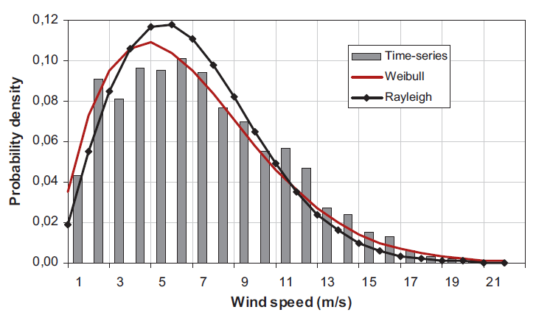

Fig. 2-1. Wind speed probability density functions for Bozcaada region [25]

## Challenges in WEC Systems

Main focus and effort during the design and implementation of wind turbines is to obtain more efficient and cost effective solutions hence to reduce the cost of energy, which can be considered as a key issue. Therefore, every detail about machine design, grid connection and other technical trend parameters have to fulfill this economical objective.

As the power scales of wind turbine increases, penetration of these energy sources into electrical grid becomes inevitable. Demand side management techniques and different storage technologies such as flywheels and batteries are developed for grid connection and disturbance support such as short term fluctuations. This integration dictates wind turbines to conform the grid codes in which quality and requirements of power plants described in terms of frequency and voltage support. Therefore, modern wind turbines with high power capacities have to keep connected and support grid in terms of voltage regulation and reactive power during the disturbances. This ability is also called low voltage ride through (LVRT) capability.

Another important challenge about wind turbines is the ease of maintenance. Reliability is related to failure rates of different parts of a wind turbine. Thus performance of every component of wind turbine determines the reliability of the wind turbine. Especially, for offshore wind turbines where access for repair and maintenance is difficult, improving reliability becomes an important key parameter during the design [12]. For example, mechanical parts which have high withstand ability for humidity is preferable for offshore wind turbines. Failure rates and corresponding downtimes for different parts of generator are obtained in [12] and given in Fig. 2-2. According to this statistics based on collected data it can be concluded that main failures and longest downtimes result from gearboxes and electrical systems.

As a rule of thumb in generator design it is important to avoid gearbox because of its mechanical parts and need for periodic maintenance and lubrication. Increased maintenance periods are big advantage for wind turbines whose locations are hard to reach such as offshore wind turbines [20]. Drivetrain of a VSCF (variable speed constant frequency) turbine generally consists of blades, low and high speed shafts, gear-box and generator. Turbine shaft can be referred as low speed shaft while generator shaft is referred as high speed shaft. Gearbox in a wind turbine system is responsible of transmission of aerodynamic power from turbine to the generator shaft. In geared type of generator, turbine blades with hub structure connected to shaft of the generator via a gear-box, which increases the rotational speed of the low-speed shaft. Gearbox allows generator to operate at high speeds, therefore smaller diameters can be used with same amount of torque needs. Gear ratio is a measure of relationship between output and input speeds of dynamic system. Drawings of nacelles of two commercial wind turbines which are geared and gearless are given in Fig. 2-3 and Fig. 2-4 respectively.

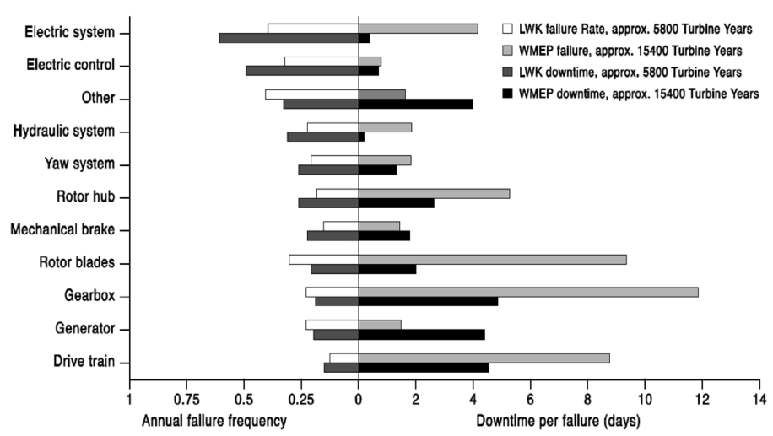

Fig. 2-2. Failure frequency and downtime for different part of wind turbine [12]

Gearbox system is the main source of mechanical faults and losses in wind turbine systems. Also, it’s necessary to make periodic lubrication and maintenance for gearbox components in order to avoid an unexpected failure. Environmental drawback of the gearbox is audible noise created by mechanical parts [13]. Because of these reasons, manufacturers and designers start to develop gearless drive systems for wind turbines from early 1990s. However, geared systems still offer cheaper solutions than large diameter direct drive systems [10].

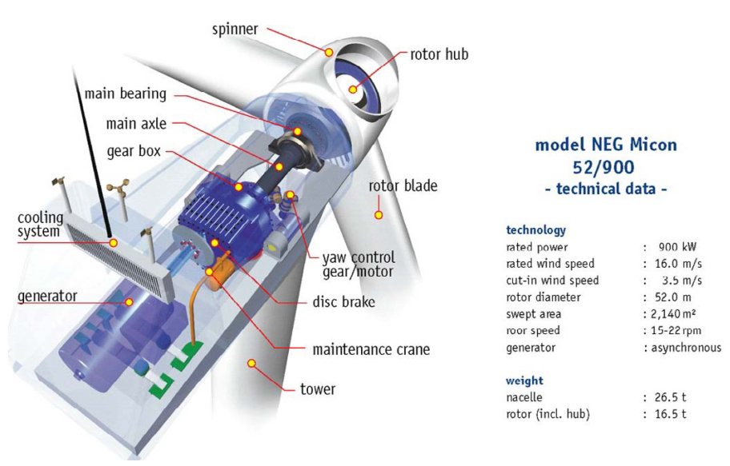

Fig. 2-3. NEG Micon wind turbine with gearbox [12]

As the name refers, in direct drive generators gearbox and all bearing structures are eliminated. Therefore, turbine blades and generator are connected on the same shaft rotating at low speed. With this eliminated gearbox and other mechanical structures, direct drive systems offer lower maintenance cost, increased efficiency and reliability. The main purposes of the direct-drive concept for wind turbines are;

* to increase the efficiency thus energy yield
* to reduce the gearbox failures
* to reduce the maintenance cost

In electrical generator design, one of the main criterion is torque. Due to tip speed limitation and natural result of gearless topology, direct drive wind turbine generators operate at low speed. Relationship between power and torque according formula which defines the output power of generator:

$P=T.ω_{m}$ (2-7)

where, *P* is the output power, *T* is the torque and *wm* is the mechanical speed of the shaft. Torque must be increase inverse proportional to decrease of angular speed in direct drive generators in order to produce same amount of power as in the geared drive case. In some designs ratio of axial length to air gap diameter, *k* is optimized [2]. According to [11], electromagnetic torque of an axial flux permanent magnet machine is proportional to outer diameter as shown in (8).

$T\sim {D_{out}}^{3}$ (2-8)

To do that when scaling up the turbine sizes, amount of material should be increased in order to maintain the air-gap against magnetic attraction forces between stator and rotor parts. This means direct drive machines are heavier and larger in diameter rather than other types of machines in order to produce the same amount of power. More material also means extra cost, which is a disadvantage for this type of generators. Torque per volume and torque per mass parameters are important during the design of the generator systems. EESG and PMSG are two main direct drive solutions exist in the market. One of the commercial direct drive EESG of Enercon is shown on Fig. 2-4. Radial flux orientation is mostly preferred among direct drive generators [20]. However RFPM can be disadvantage when allocated space for generator is limited for specific applications such as nacelle or electric vehicle wheel motor. Transverse flux PM generators can produce higher torques with lower copper losses. However complicated construction is an important penalty for transverse flux option, especially when maintenance problems are taken into account. Direct drive axial flux type permanent magnet machines are advantageous in torque to volume ratio among other machine topologies while torque per mass values are not much attractive. Torque per volume advantage is due to shorter axial length and compact structure rather than radial flux counterpart. Torque per mass disadvantage is related to large diameter which is a penalty of this type of generators. Because of reasons aforementioned above, trend is going through the high torque direct drive generators as it eliminates gearbox losses and minimizes maintenance and repair cost hence increases the overall efficiency and reliability of the system.

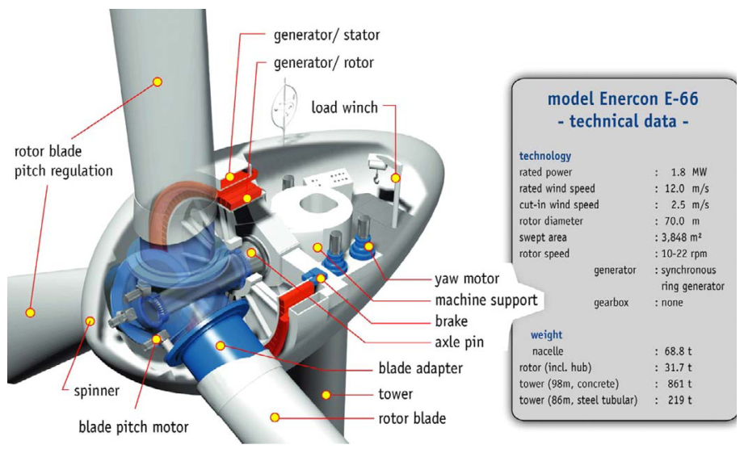

Fig. 2-4. Enercon E-66 wind turbine without gearbox [12]

Modularity on the other hand, is related to availability of maximum portion of mechanical or electrical structure of generator during the failure periods. With the rapidly increased power levels of 5 MW and above for per turbine, nowadays trend is going through the modular multi-level power electronic converters and modular machine structures for large wind turbine generators [26-28]. Mechanical modularity can be considered as operating parallel machines instead of one bulky generator. Contrary to conventional generators, modular generators have the ability of continue to operate with its healthy modules under fault conditions of defective modules. Therefore, reliability and overall efficiency is increased. Challenges for increasing efficiency of wind turbines from the control point of view can be considered as fault monitoring and diagnostic, forecasting error and predictive controls [29].



## Current Wind Turbine Generator Technologies

In this section, generators are categorized according to their mechanical and electrical properties. In mechanical categorization, drivetrain approach is considered ie. whether drivetrain includes gearbox or not. In electrical categorization, most used generator types in WECs namely induction and synchronous generators are considered in terms of wind turbine point of view. Thus, main approach in this part when describing their properties is based on whether they are induction or synchronous generators. Wind turbines are mainly categorized in the literature according to their rotational speeds. These speed categories are fixed speed, limited variable speed or variable speed. Variable speed configuration is the most used one among other speed options because it’s more grid-supportive by means of power electronic converter it provides [5]. These type of turbines are capable of operating at different wind speeds and more flexible in terms of torque and reactive power control [13].

## Induction Generators

## Squirrel Cage Induction Generators (SCIG)

This type of generator can be used with both fixed (also known as Danish Concept) and variable speed. However, SCIGs are commonly used for constant speed operation. The most common configuration of this generator consists of three stage gearbox connected to SCIG and compensating capacitors [12]. Generator speed is determined according to grid electrical frequency. Sometimes soft-starter can be used after the generator for smoother grid connection [14]. This type of SCIG is given in Fig. 2-5.

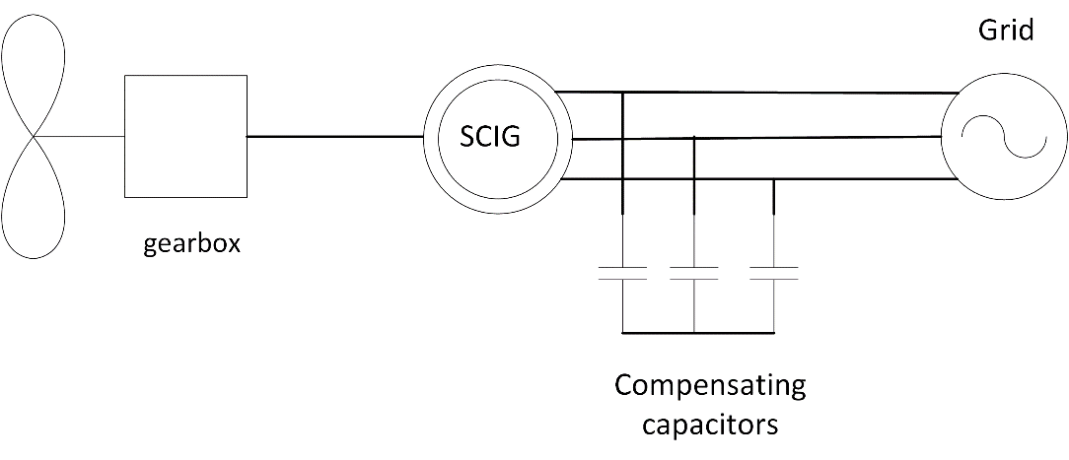

Fig. 2-5. SCIG Danish concept wind turbine schematic

Robustness, off-the-shelf parts, lower investment costs, stable operation and lower maintenance makes SCIG preferable in WECs. But in order to get more efficient operation SCIG should be constructed with low number of poles because high number of poles construction becomes a mechanical drawback for SCIG. Besides, high number of poles leads to higher leakage flux losses in practical. Therefore gear-boxes are generally used with SCIGs. Due to fixed speed operation above rated wind speeds, limited output power is another drawback of this system. Lack of power electronic unit results in poor capability of reactive power control and voltage level problems. Need for magnetizing current in order to create magnetic field for stator, makes induction generator reactive power-dependent. Capacitor banks or Static Synchronous Compensators (STATCOM) are commonly used for reactive power compensation with SCIGs. Wind speed fluctuations and tower-shadow effect directly converted in torque dips and fatigue loads on turbine sub-mechanical systems [5, 30].

In variable speed applications of SCIG back-to-back voltage source converters (VSCs) are employed in order to meet the grid codes [3]. Schematic diagram of this type WEC is given in Fig. 2-6. Generator given in Fig. 2-3 was also a constant speed SCIG namely, Danish Concept.

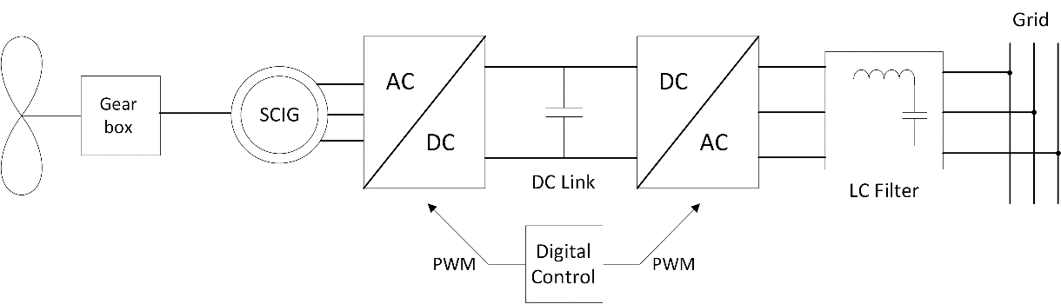

Fig. 2-6. SCIG with back-to-back VSC converter

## Wound Rotor Induction Generators (WRIG)

Wound rotor induction generators are also known as the Optislip concept and have been applied by Vestas since 1990s [14]. These type of generators are used for limited variable speed applications, thus there will be dynamic slip control [3].This control is applied by connecting electronically controlled resistor blocks to rotor of the generator. Mechanical loads are reduced in this type of configuration because of controllable speed. Slip denotes the relation between the rotor speed and synchronous speed. It is given by the formula as follows,

$s=\frac{N_{s}-N_{r}}{N_{s}}$ (2-9)

where, *s* is the slip, *Ns* is synchronous speed, *Nr* is rotor speed. Higher slip magnitudes indicate higher power losses on rotor connected resistors hence lower efficiency. Gearboxes in this system can have multiple stages just as the SCIG case. Also there exist shunt capacitors connected to line for compensation purposes.

Typical WRIG schematic diagram with these capacitors is shown in Fig. 2-7. It can be concluded that main advantage of this concept is limited variable speed operation ability due to resistors connected series with power electronic converter. The main disadvantage of WRIG is lower efficiency due to heat losses on resistors while increasing variable speed range. Vestas V80 wind turbine has the output power of 2 MW and utilizes WRIG technology. An image of this wind turbine is given in Fig. 2-8.

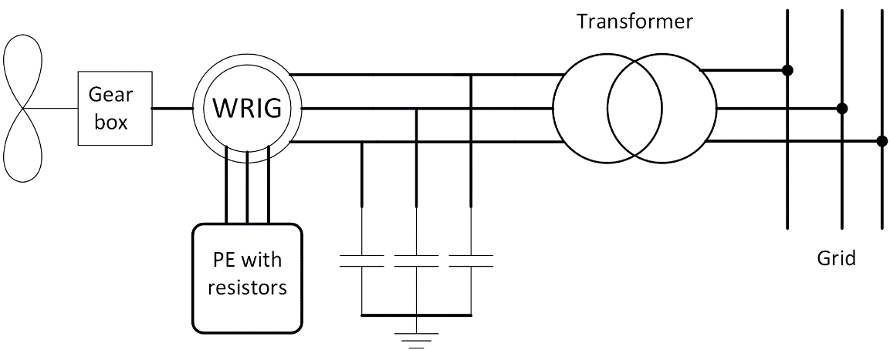

Fig. 2-7. WRIG schematic diagram

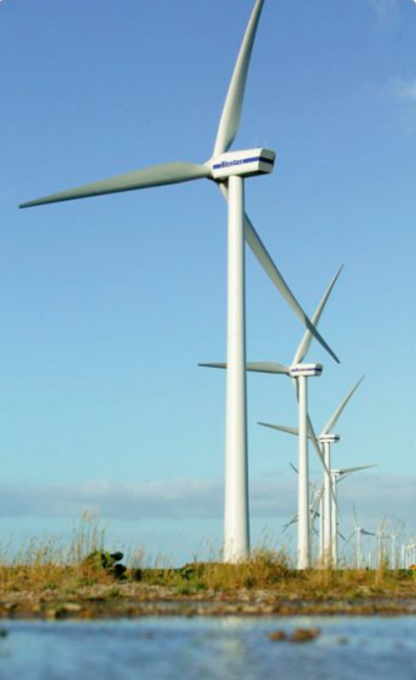

Fig. 2-8. Vestas V80 wound rotor induction generator (Courtesy of Vestas) [15]

## Doubly-fed Induction Generator (DFIG)

Among wind turbine generator types, doubly-fed induction generator system with 3 stage gearbox (DFIG-3G) is the most common configuration at present [4]. Although it consists more complicated power electronic control, it can control active and reactive power flow within supply side or rotor side. Stator is connected to grid via transformer while rotor is connected to grid via power electronic converter blocks. This power electronic converter is rated at fraction (usually between 20-30%) of generator power [16], therefore these converters are called as partial scale converter. The main objective of this power electronic block is to adjust speed range and grid reactive power support. Sometimes second PGSC (parallel grid side converter) is used parallel with dc-link in order to control unbalanced conditions better. Configuration of DFIG is shown in Fig. 2-9. Multistage or single stage gearbox can be used with DFIGs.

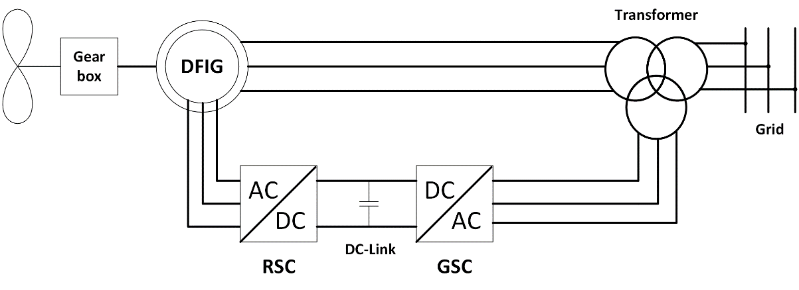

Fig. 2-9. Conventional grid connected DFIG, RSC: Rotor side converter, GSC: Grid side converter

Slip rings and gearbox are the main disadvantages of this generator. DFIGs are not suitable for direct drive because of efficiency problems. As mentioned before, as machine rotational speed decreases, torque must be increase in order to produce same amount of power. Therefore generator size should be increased. However, as the diameter of DFIG increases airgap also increase and magnetizing current increases. Higher magnetizing current means lower efficiency. Besides, generators with larger diameters have large number of poles hence leakage flux problems can occur just as in the SCIG case. Stator of the DFIG is directly connected to the grid, thus possible active and reactive power support can be realized via partial scale converter of rotor. Back-to-back converter seen in Fig. 2-9 can be used with crowbar in order limit the current and provide fault handling capacity [16]. A commercial DFIG wind turbine Nordex N131/3600 is given Fig. 2-10. It’s rated at 3.6 MW and has 3 stage gear-box.

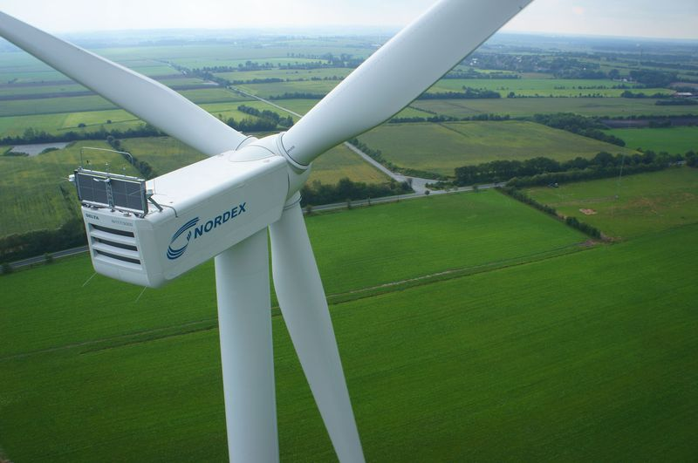

Fig. 2-10. NORDEX N131 (courtesy of NORDEX) [45]

Variable speed operation and efficient converter with active/reactive power control rather than WRIG, low price, easy off-the-shelf availability are main advantages of DFIG. Dependency on gearbox, complex power electronic and fractional scale adjustable reactive power control, slip rings, high stator peak torques during fault conditions, weak LVRT capability than synchronous generators with full-scale converters are the main disadvantages of this type of wind turbine generators. Especially with the increasing importance of grid integration, it’s expected that DFIGs will become less preferable [12, 31]. In Fig. 2-11, market share of different wind turbine generator technologies for Europe can be seen. As it can be seen on figure, market share of DFIG has a decreasing trend due to the aforementioned disadvantages above.

Fig. 2-11. Market share of different wind turbine generators for Europe between 2006 and 2015 [46]

## Synchronous Generators

## Electrically Excited Synchronous Generators (EESG)

Synchronous generators for wind turbines connected to grid via full scale back-to-back power electronic converters. In wound rotor synchronous generators (WRSG), additional partial scale converter is used for rotor DC excitation for required field [16]. Therefore WRSGs are also called as electrically excited synchronous generators (EESG). Rotor of synchronous generator can be excited permanent magnets (PM) also, but this type of generator will be described in the next subsection. One of the most prominent manufacturer of EESG is Enercon. In Fig. 2-12, one of the gearless Enercon wind turbine can be seen. EESG of this commercial wind turbine has 4.2 MW of output power and rotor diameter of 127 meters. One of the main advantages of this concept is that EESG can be operated with variable speed applications with suitable grid connected power electronic blocks. Additionally, this machine type has cost advantage compared to the direct-drive PM machine due to eliminated PM cost. Power converter losses and high cost of the full scale converter are the main disadvantages of this power take off system. But, it can provide wide control ability of wind turbine generator [14]. It can be either geared or direct-driven. However, direct-driven concept is more popular due to elimination of gearbox losses and increased efficiency. It is manufactured in large size and number of poles, therefore EESG can be heavy and expensive solution. Schematic diagram of EESG is given in Fig. 2-13 with gearbox depicted with dashed lines in order to show it’s optional for EESG.

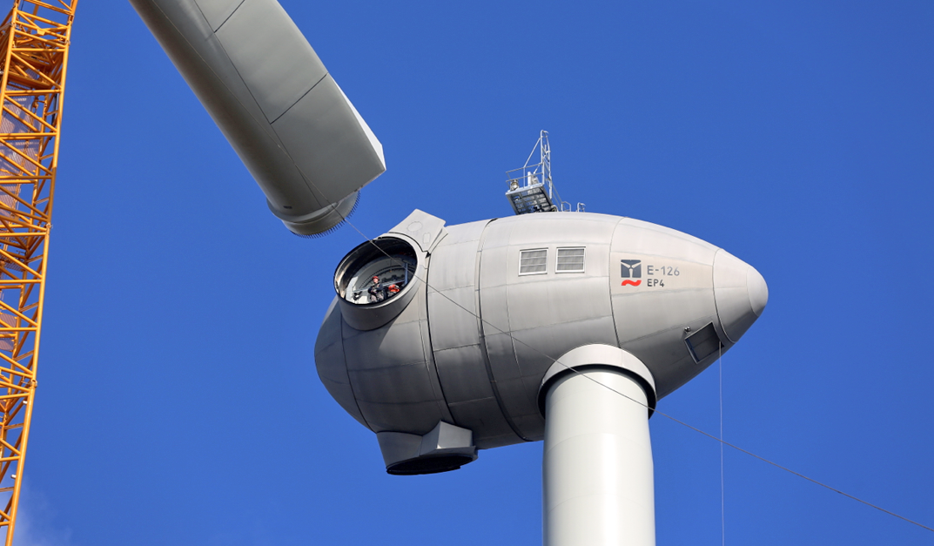

Fig. 2-12. Enercon E-126 EP4, 4.2 MW wind turbine during the installation [17]

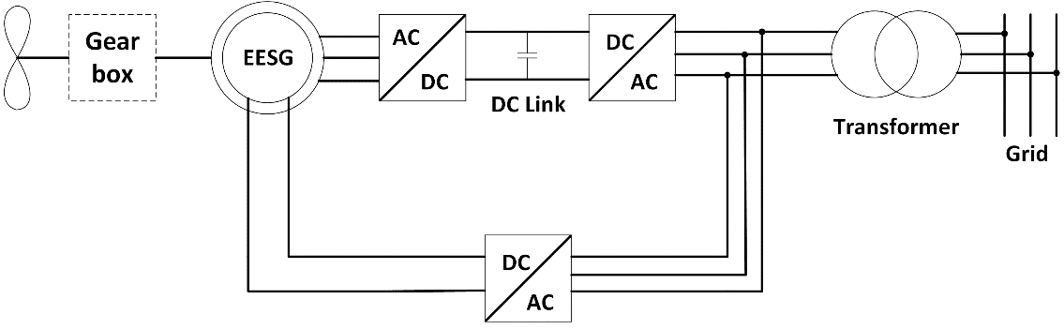

Fig. 2-13. EESG-Electrically Excited Synchronous Generator grid connection

## Permanent Magnet Synchronous Generators (PMSG)

In this generator type field excitation is provided by permanent magnets instead of the DC excited field winding. Permanent magnet synchronous generators are available in both direct-driven and multi-stage geared versions. In geared version, gearbox compensate the space and volume disadvantage caused by direct drive concept. Direct drive PMSGs are preferred because of their higher energy yield and higher power-to-weight ratios than electrically excited generators. Therefore, overall efficiency is increased in direct drive PMSGs due to its robust structure [18]. Due its full scale converter, fault-ride-through capabilities and reactive power support ability are important advantages of PMSG. Full-scale converter also allows generator to operate at different frequencies [12]. However, high prices of permanent magnets and fluctuations in these prices, as occurred in 2010 due to China’s precautive actions [12], can be considered as a disadvantage of this concept. Demagnetization risk of PMs is another disadvantage of PMSG. As a good alternative for PM excited synchronous generator, popularity of EESG depends on the PM prices. It can be said that reduction in magnet prices and disadvantages discussed in EESG section cause EESG less preferable against permanent magnet synchronous generators.

Recently, capacity of PMSG wind turbines has increased up to nearly 10 MW [32, 33]. Schematic of PMSG with multiple stage gearbox is given in Fig. 2-14 below. Vestas offshore wind turbine V164 whose output rated power is 8MW, given in Fig. 2-15.

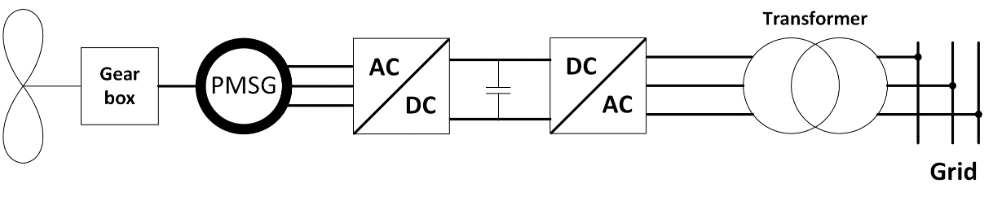

Fig. 2-14. Permanent magnet synchronous generator with gear-box and full scale power electronic converter



Fig. 2-15. Vestas V164 8MW Offshore wind turbine[33]

As mentioned before in direct drive section, gear box structure causes mechanical loss and requires periodical maintenance. Once gearbox fails, wind turbine can’t able to produce energy. Hence this results in downtime losses. Maintenance and repair losses makes wind turbine inefficient and expensive investment. Therefore, the trend is using direct-driven or single stage gearbox with PMSGs [10, 18]. Single stage gearbox still have mechanical losses rather than gearless system. However, it reduces the rotor diameter and total mass of the direct-driven version.

In direct-drive generators, since the rotational speed is very low, diameters are increased in order to obtain higher torque values, hence power levels stay same or goes up. However, increase in diameter and total generator volumes are not feasible for reliability, modularity and transportation. A Germany originated company named Multibrid, designed and commissioned a PMSG with one stage gearbox, Multibrid M5000. Main focus is to reduce the large size of multi MW large direct drive PMSGs. However, this design has the disadvantage of gearbox but cheaper than direct-drive generator. In Fig. 2-16, a picture of 5 MW Multibrid M5000 wind turbine is given.

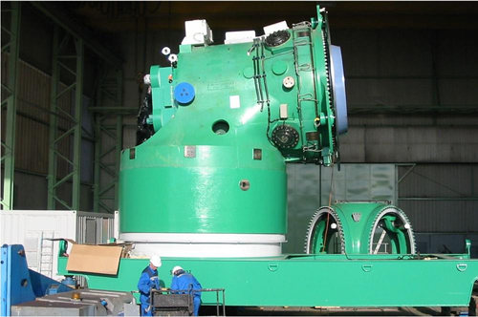

Fig. 2-16. Multibrid M5000 5MW wind turbine generator(Courtesy of Multibrid and Areva) [19]

It’s can be concluded that direct-drive technology among PMSG are gaining attention in last decade due to increased efficiency and reliability issues especially for offshore wind turbines[34-36]. In Fig. 2-17, schematic of direct drive PMSG is given.

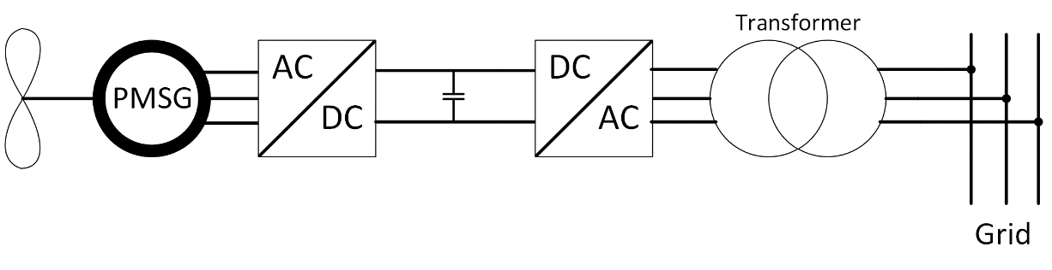

Fig. 2-17. Schematic of direct-driven PMSG

Permanent magnets in PMSGs are arranged in different configuration related to their flux path. These are called as radial flux, axial flux and transverse flux. In radial flux concept, path of the magnetic flux is perpendicular to the direction of the rotor shaft. In axial flux concept, path of the magnetic flux is parallel to the direction of the rotor shaft. Finally in transverse flux concept, path of the magnetic flux is perpendicular to the direction of the rotor rotation. Additionally, PM machines can be classified according to their mechanical structures such as slot type and stator/rotor position [20].The sections of a PMSG parts can be classified as active and inactive parts. Active part consists of electromagnetic elements in machine such as PMs, iron core and copper. Inactive part consists of mechanical parts such as steel, shaft and other mechanical frame structures.

In this thesis work, direct drive PMSG is chosen for the design because of its higher energy yield, improved reliability, higher overall efficiency, relatively long maintenance periods and better fault ride-through capability rather than the other electrically excited and multistage geared generator counterparts. Reliability and availability can be increased by developing modular and fault tolerant PMSG. Modularity will be discussed and explained in next subsections.

## Flux Orientations in PMSG based Systems

As mentioned before, in PMSG based systems the main electromagnetic flux on rotor side is provided by rare-earth permanent magnets. Therefore, the flux paths for these permanent magnets and active parts of the generator is important in terms of evaluating magnetic equivalent circuit of system. In this subsection, different flux orientations and considerations of PM based synchronous generators will be given. To do this, subsection is divided into three parts, namely radial flux, axial flux and transverse flux sections.

## Radial Flux (RFPM)

In the radial flux configuration, permanent magnets are arranged so that magnetic flux passes the airgap in radial direction. Radial flux configuration is the most common concept in permanent magnets based large direct drive synchronous generators, due to their high torque density and simple structure [13]. If PMs are mounted on the rotor surface this type is called as surface mounted permanent magnet machine. Otherwise PMs are placed in slots (buried) of rotor part, aiming to concentrate the flux especially when low remanent flux density magnets are used and still high airgap flux density is needed. RFPM generators can be sometimes constructed with outer rotor inner stator configuration in order to utilize high number of poles with increased cooling capability of outer rotor surface [14]. Iron cored and air-cored are two core types used with inner rotor and outer rotor configuration, respectively. Diameter of RFPM can be adjusted with longer axial length. A typical radial flux surface mounted PM generator arrangement is given in Fig. 2-18. Buried PM version of RFPM is given in Fig. 2-19. As seen on figures, flux crosses the airgap in radial path in both configuration.

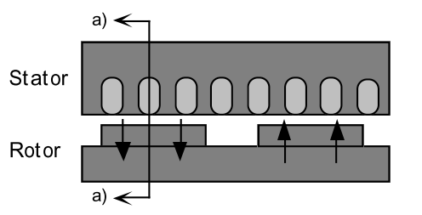

Fig. 2-18. RFPM with surface mounted permanent magnets [21]

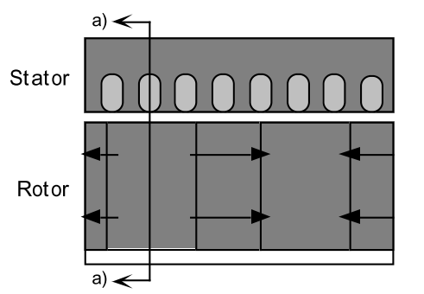

Fig. 2-19. RFPM with buried permanent magnets for flux concentration [21]

RFPM generator can be manufactured in small diameters due to adjustable axial length as aforementioned above. However, long axial length is disadvantage for nacelle and space of wind turbine generator. Additionally, thermal expansion of rotor and stator parts may be problematic in determining air gap clearance [21]. Internal rotor type is the most used RFPM in industry applications. Complete view of conventional inner rotor surface mounted PM type radial flux machine is given in Fig. 2-20.

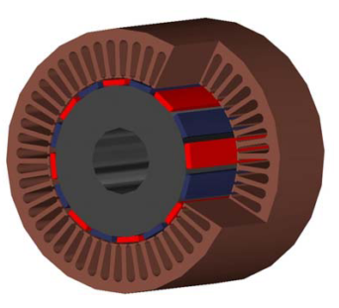

Fig. 2-20. Conventional internal rotor RFPM complete view [22]

## Axial Flux (AFPM)

Starting from early 90s, AFPM has been extensively used as an alternative for radial flux counterpart [37-40]. In axial flux permanent magnet generators (AFPM) magnetic flux crosses the air gap in the axial direction. The main advantage of AFPM is that it has relatively shorter axial length, therefore higher torque per volume ratios are achieved [13]. In multistage variations of this machine, outer diameter can be limited without decreasing the torque density significantly. Ratio of inner diameter to outer diameter should be chosen carefully in order to achieve higher output power [24]. This property is preferred when working with limited nacelle space. Adjustable planar air gap is another advantage over the radial flux machines [23]. There are different types of stator/rotor configurations of AFPMs. AFPMs can be classified as slotted and slotless machines, considering the stator winding position. A table showing the various types of AFPM generators according to different criterions is given in Fig. 2-21.

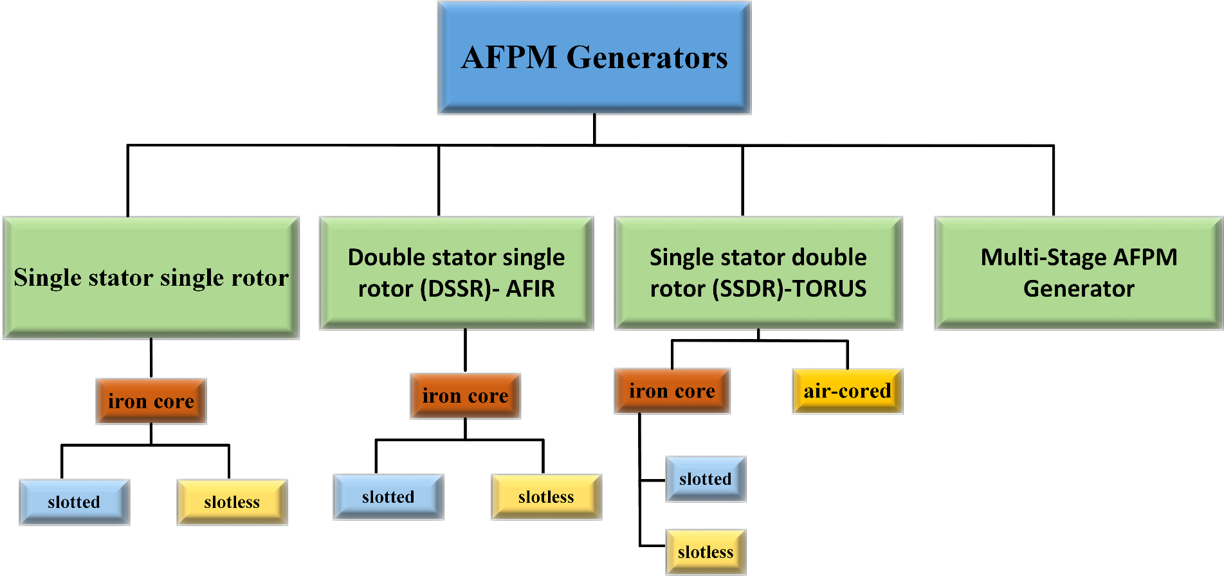

Fig. 2-21. Classification of AFPM generator

Most basic structure of AFPM is the single stator single rotor structure as given in Fig. 2-22. However, strong magnetic attraction force between stator and rotor compelled designers to design the axial structure of the generator with multiple stators/rotors and slotless variations in order to balance the magnetic attraction forces mentioned above [24]. However, attraction and thrust forces are equalized thanks to balanced rotor discs and non-slotted stator. Non-slotted special type AFPM generator, which is called TORUS is given in Fig. 2-23. Rotor of this type of generator consist of two discs with PMs mounted on them and stator consisted of iron core and wound coils. In some of the literature, this type of machine is referred as single stator double rotor (SSDR) [24, 40]. Disadvantage of that version is stator iron core losses.

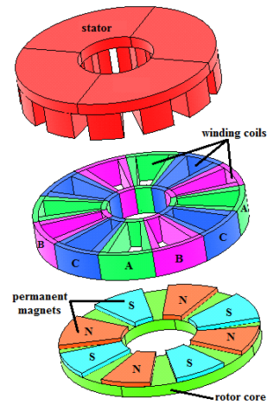

Fig. 2-22. Single sided configuration of AFPM (single stator and single rotor) [40]

Due to its short axial length, AFPMs can be organized with multiple generators on the same shaft axis in order to improve fault tolerance and reliability. AFPMs are relatively advantageous rather than RFPM when aspect ratio of machine (diameter/length) is high, ie. large diameter of disc-shaped generators are used [23].

Cogging torque is eliminated due to slotless structure of AFPM generator. In our study slotless air-cored stator is used with axial flux permanent magnet arrangement. Also in the proposed generator modular design is used. Therefore, parallel generators can be added axially.

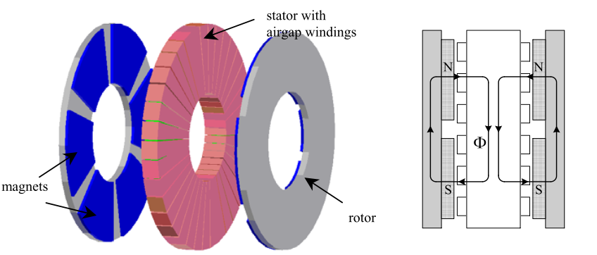

Fig. 2-23. Non slotted TORUS axial flux permanent magnet overview (left) and path of generated flux by permanent magnets (right) [23]

There are two types of slotted TORUS concept: TORUS-NN and TORUS-NS. NN and NS letters used for define magnet placements on rotor discs. Machine overviews and flux paths of both concepts are given in Fig. 2-24 and Fig. 2-25. Main differences between them are flux paths and stator core axial thickness. In our study main aim is to eliminate iron core because of its core losses and weight. In coreless AFPMs iron losses and torque pulsations are less than other types of AFPMs. General view of coreless TORUS type AFPM generator is given in Fig. 2-26. Detailed schematics of proposed coreless, outer rotor AFPM and related flux organizations will be given in Chapter 3.

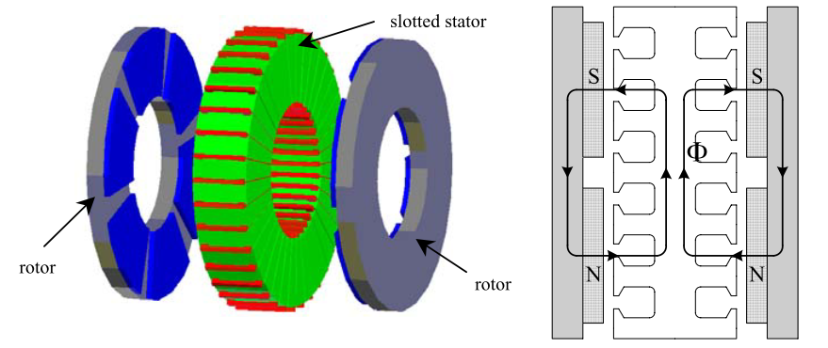

Fig. 2-24. NN-type slotted TORUS axial flux permanent magnet overview (left) and path of generated flux by permanent magnets (right) [23]

As mentioned before in RFPM part, AFPM generator can also have different stator and rotor configurations. In TORUS configuration, we mentioned about two rotor discs which are positioned at the outer region of generator. However, axial flux inner rotor (AFIR) type axial flux generators have two stator blocks at the outer region and one rotor block at the inner region. In some of the literature, this type of machine is referred as double stator single rotor (DSSR) [24, 40].AFIRs can have slotless and slotted versions, just as in the TORUS configurations.

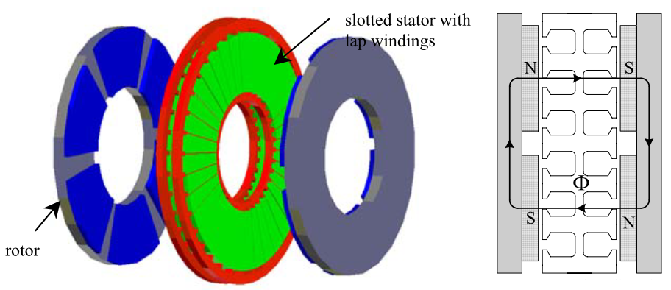

Fig. 2-25. NS-type slotted TORUS axial flux permanent magnet overview (left) and path of generated flux by permanent magnets (right) [23]

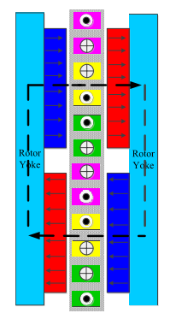

Fig. 2-26. NS-type coreless TORUS axial flux permanent magnet overview [24]

Stator configuration is similar to as it was in TORUS concept. But, in rotor part magnets are not mounted on rotor disc. Instead, permanent magnet formed an interior type structure. Overview and flux paths of slotless AFIR and slotted AFIR are given in Fig.2-27 and Fig. 2-28, respectively.

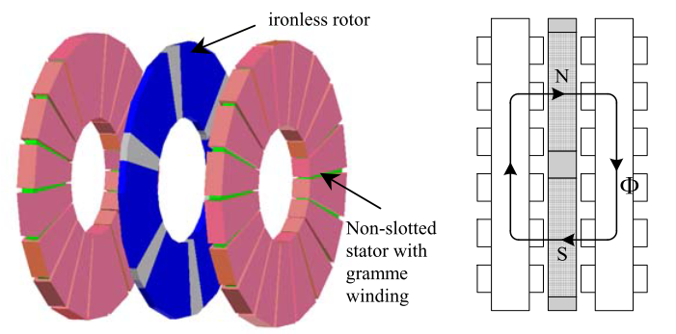

Fig. 2-27. Slotless AFIR overview (left) and path of generated flux by permanent magnets (right) [23]

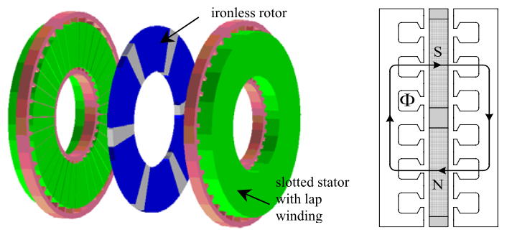

Fig. 2-28. Slotted AFIR overview (left) and path of generated flux by permanent magnets (right) [23]

AFPMs generally used with multi-stage configurations in order to increase torque and output power. In this configuration stages of generators stacked axially on the same shaft with (n) stator discs and (n+1) rotor discs, where “n” represents the number of stages. Multi-stage configurations of AFPMs are can again be classified as slotless and slotted structures. Properties of these structures are same as that of single stage TORUS and single stage AFIR type slotless and slotted configurations. An example of 2-stage AFPM generator with slotted stator configuration is given in Fig. 2-29. Multi-stage AFPM configurations can be used in ship propulsion and high speed generators. Similar to TORUS, multistage AFPM can be also constructed in ironless fashion. Flux path of the coreless multistage AFPM generator is given in Fig. 2-30. Detailed information about multistage slotted and slotless configurations of multistage AFPMs can be found in literature [20-24].

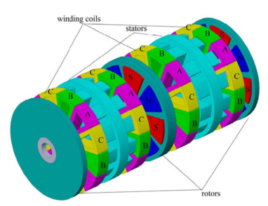

Fig. 2-29. Multistage AFPM generator [24]

Apart from the AFPM topologies discussed above, there are some other novel topologies which uses field control techniques. Another novel topology is double sided hybrid AFPM generators. These variations are not in the scope of this study but they can be found in literature [23, 40-44].

To summarize, the advantages of AFPM are: shorter axial length, reduction in cogging torque and torque quality problems, high torque per volume ratio, simplicity in adjusting airgap due to axially stacked stage/stages. Besides, lower torque per weight, large outer diameter as mentioned above, problematic core manufacturing process and higher cost than conventional RFPM are the main disadvantages of AFPM for suitable wind turbine generator [20].

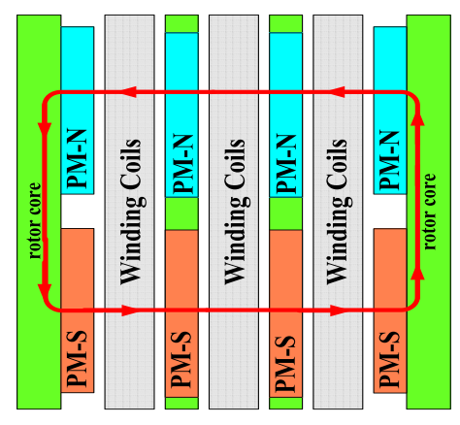

Fig. 2-30. Coreless multistage AFPM generator flux path [40]

In this thesis, coreless version of axial flux permanent magnet machine is studied due to its advantages of axial length and high torque per volume. In this type of machine, generator blocks are added axially to form the whole system. Magnets are placed on the surfaces of C-shaped rotor cores, facing the air-gap stator windings. Stator part consist of air cored concentrated windings. Detailed information about proposed generator and flux patterns will be given in following chapters.

## Transverse Flux (TFPM)

In transverse flux machines, the main path of magnetic flux is perpendicular to the rotation of the rotor part. It’s suitable for direct drive wind turbine application, considering its high torque density. Although high torque density provides efficient utilization of active materials in TFPM, when airgap is increases cost advantage of this concept decreases due to reduced force density. Sample view of TFPM is given in Fig. 2-31. Three dimensional flux path in this type of machine is given in Fig. 2-32. This kind of flux path becomes problematic during analysis and construction.

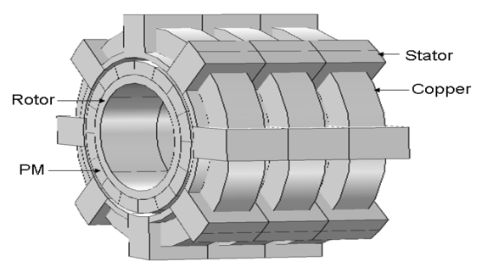

Fig. 2-31. Transverse flux machine view [25]

The main advantages of this concept are higher torque per mass ratio, simple winding construction among other PMSGs and available space for more windings than RFPM and AFPM. However, manufacturing issues due to the complex structure and low power factor eliminates TFPMs from the wind turbine generator configurations [13, 24]. Design improvements must be done in order to use TFPMs in wind turbine generators efficiently.

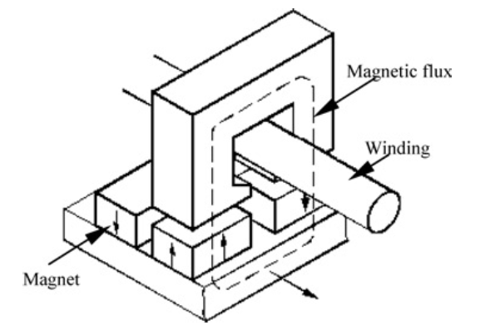

Fig. 2-32. Transverse flux machine three dimensional flux path [14]

## Importance of Modularity in WEC Systems and AFPM

Modular construction of electrical machines aims to get easier assemble and disassemble operations during maintenance and repair conditions. This concept also allows each module to work individually thus better fault-tolerance. In our study, modularity term has two meanings: axially stacked generators and C-shaped modular cores. First one is related to length advantage of selected generator type. By this modular structure technique, identical machines can be stacked in order to increase torque and power output under limited outer diameter conditions. These stacked generator sets can be grouped in parallel fashion, thus overall reliability of the system increases. Additionally, these axially stacked generators gives fault-tolerance to whole system. For instance, if one or more generators become defective during operation, not all but healthy stacks will continue to operate until the fault is cleared. Therefore, frequency of downtimes will reduce and efficiency of the wind turbine will increase. The latter is related to modular structure of the machine. For example, under fault conditions, defective cores can be changed and/or maintained easily. As mentioned in earlier parts, modularity is related to reliability. In other words, wind turbine generator system which constructed in modular fashion, provides better efficiency. Reliability is related not only with modularity of machine but properties of sub-module parts such as thermal issues about power electronics. Nowadays with the increased importance of grid connection safety and stability, efficiency and reliability become a critical properties of wind turbines. For instance, in offshore wind turbines it’s very important to operate the system continuously and to utilize the sub-module parts efficiently. Because, maintenance difficulty related to location is a big disadvantage for offshore wind turbines.

Modularity is not only related to technical problems but also related to economic issues. When large diameters and single bulky structure is considered, modular solutions for permanent magnet direct drive generator topologies become preferable. For example, using multistage generators at relatively low output power ratings is a better solution than using a single huge generator in terms of production, transportation and installation costs. Additionally, crane costs for installation and maintenance will reduce due to low mass of single stack of generator. Another important advantage of modularity is that downtime costs, which is the cost of missing electricity generation income during the downtime of the turbine due to an unexpected failure, can be reduced. As aforementioned in previous parts, a modular axial flux permanent magnet generator is proposed for wind turbine generator systems. Modularity and reliability are the key parameters for our proposed generator.

## Conclusion

In this chapter, fundamental equations and issues of wind energy harvesting technology are summarized. After this introduction part, the main challenges and critical issues of wind turbine systems are given. According to literature [26-28], generator technology gaining more attention than its past by reaching megawatts of power capability per turbine. Therefore its design is the main focus point of both this study and current research activities on this area. In the following sections, general overview of the most common wind turbine generator systems are given in detail in order to find suitable generator for MW-level wind turbines. Gearboxes are the main source of losses and faults in wind turbines. Induction generators and especially the DFIG with gearbox is the most common generator type because of its price and experience in both field and production. However, direct drive permanent magnet synchronous generators (PMSG-DD) are found more reliable and feasible solution in terms of efficiency, reliability and fault-ride-through capability. Thus, direct drive PMSG is chosen for the proposed design in this study. Then, flux orientations in PMSGs are discussed in this chapter and axial flux version is preferred among other types of PMSG because of its higher torque over volume ratio and axial length advantages. In this study, axially stacked modular generator with direct drive concept is preferred because of this reliability view. Additionally, using axially stacked generators in AFPM generator configuration can increase the total output power and torque under limited outer diameter conditions. Advantages and disadvantages of every concept and generator types are given in related sub-sections.

After detailed review of generator types and flux orientations in PMSGs, modularity concept is discussed. It’s been concluded that utilizing the generator in modular fashion will increase the efficiency and reliability. There are also economic aspects of using modular technologies in wind turbine design. Installation costs, crane costs for maintenance and installation, transportation costs and downtime costs can be reduced with modular design concept. Detailed design calculations of proposed direct-drive modular axial flux permanent magnet synchronous generator will be given in the next chapter.

**REFERENCES**

**[1]** Y. Xia, K. H. Ahmed and B. W. Williams, "Wind Turbine Power Coefficient Analysis of a New Maximum Power Point Tracking Technique," in IEEE Transactions on Industrial Electronics, vol. 60, no. 3, pp. 1122-1132, March 2013.

**[2]** S. Engström and S. Lindgren, “Design of NewGen direct-drive generator for demonstration in a 3.5 MW wind turbine”, EWEC (European Wind Energy Conference & Exhibition, Milan, Italy, May 7-10 2007.

**[3]** O. P. Mahela, A. G. Shaik, Renewable and Sustainable Energy Reviews 57, 260-281 (2016).

**[4]** Xu Yang; Patterson, D.; Hudgins, J., "Permanent magnet generator design and control for large wind turbines," in Power Electronics and Machines in Wind Applications (PEMWA), 2012 IEEE , vol., no., pp.1-5, 16-18 July 2012.

**[5]** Guidelines for design of wind turbines, DNV, Second Edition

<http://www.cwpc.cn/cwpp/files/7313/9823/7381/Technology_Wind_Turbine_Design_Guidelines_for_Design_of_Wind_Turbines.pdf> Accessed: 24/04/2017

**[6]** Keegan, M. H., Nash, D. H., & Stack, M. M. (2013). On erosion issues associated with the leading edge of wind turbine blades. Journal of Physics D: Applied Physics, 46(38), 383001.

**[7]** Rossouw, Francois Gerhardus, “Analysis and Design of Axial Flux Permanent Magnet Wind Generator System for Direct Battery Charging Applications” ,MS Thesis, 2009.

**[8]** WindyNation Website

<https://www.windynation.com/jzv/inf/tip-speed-ratio-how-calculate-and-apply-tsr-blade-selection> Accessed: 24/04/2017

**[9]** METU Dept. of Aerospace Engineering, “AE462-Design of Aerospace Structures Lecture Notes”, <http://www.ae.metu.edu.tr/~ae462/12/IEC%2061400-1.pdf> Accessed: 24/07/2017

**[10]** H. Polinder, F. F. A. van der Pijl, G. J. de Vilder and P. J. Tavner, "Comparison of direct-drive and geared generator concepts for wind turbines," in IEEE Transactions on Energy Conversion, vol. 21, no. 3, pp. 725-733, Sept. 2006.

**[11]** J.F. Gieras, R. Wang, M. J. Kamper, Axial Flux Permanent Magnet Brushless Machines, Second Edition.

**[12]** H. Polinder, "Overview of and trends in wind turbine generator systems," 2011 IEEE Power and Energy Society General Meeting, San Diego, CA, 2011, pp. 1-8. doi: 10.1109/PES.2011.6039342

**[13]** “Design and Optimization of High Torque Density Generator for Direct Drive Wind Turbine Applications”, MS Thesis, R. Zeinali, METU,2016.

**[14]** H. Li and Z. Chen, "Overview of different wind generator systems and their comparisons," in IET Renewable Power Generation, vol. 2, no. 2, pp. 123-138, June 2008. doi: 10.1049/iet-rpg:20070044

**[15]** Direct industry,

<http://pdf.directindustry.com/pdf/vestas/v80-20-mw-brochure/20680-53605.html>

Accessed: 24/07/2017

**[16]** M. Liserre, R. Cardenas, M. Molinas and J. Rodriguez, "Overview of Multi-MW Wind Turbines and Wind Parks," in IEEE Transactions on Industrial Electronics, vol. 58, no. 4, pp. 1081-1095, April 2011. doi:10.1109/TIE.2010.2103910

**[17]** The Official Website of Enercon GmbH,

<http://www.enercon.de/fileadmin/_processed_/csm_titel_ep4_1d94c9e268.png>

Accessed: 24/07/2017

**[18]** Ming Cheng, Ying Zhu, The state of the art of wind energy conversion systems and technologies: A review, Energy Conversion and Management, Volume 88, December 2014, Pages 332-347, ISSN 0196-8904.

**[19]** Wind Energy- The Facts(WindFacts) webpage,

<https://www.wind-energy-the-facts.org/alternative-drive-train-configurations.html>

Accessed: 24/07/2017

**[20]** D. j. Bang, H. Polinder, G. Shrestha and J. A. Ferreira, "Promising Direct-Drive Generator System for Large Wind Turbines," 2008 Wind Power to the Grid - EPE Wind Energy Chapter 1st Seminar, Delft, 2008, pp. 1-10.  
doi: 10.1109/EPEWECS.2008.4497321

**[21]** Grauers, A. (1996) Design of Direct-driven Permanent-magnet Generators for Wind Turbines. Göteborg : Chalmers University of Technology (PhD Thesis - School of Electrical and Computer Engineering, Chalmers University of Technology, Göteborg, Sweden, no: 292).

**[22]** A. Parviainen, M. Niemela, J. Pyrhonen and J. Mantere, "Performance comparison between low-speed axial-flux and radial-flux permanent-magnet machines including mechanical constraints," IEEE International Conference on Electric Machines and Drives, 2005., San Antonio, TX, 2005, pp. 1695-1702.  
doi: 10.1109/IEMDC.2005.195948

**[23]** Aydin, M., Huang, S., Lipo, T.A., 2004. Axial Flux Permanent Magnet Disc Machines, Research Report. Madison, USA.

**[24]** S. Kahourzade, A. Mahmoudi, H. W. Ping and M. N. Uddin, "A Comprehensive Review of Axial-Flux Permanent-Magnet Machines," in Canadian Journal of Electrical and Computer Engineering, vol. 37, no. 1, pp. 19-33, winter 2014. doi: 10.1109/CJECE.2014.2309322

**[25]** A. Chen, R. Nilssen and A. Nysveen, "Performance comparisons among radial flux, multi-stage axial flux and three-phase transverse flux PM machines for downhole applications," 2009 IEEE International Electric Machines and Drives Conference, Miami, FL, 2009, pp. 1010-1017. doi: 10.1109/IEMDC.2009.5075328

**[26]** S. Debnath, J. Qin, B. Bahrani, M. Saeedifard and P. Barbosa, "Operation, Control, and Applications of the Modular Multilevel Converter: A Review," in IEEE Transactions on Power Electronics, vol. 30, no. 1, pp. 37-53, Jan. 2015.  
doi: 10.1109/TPEL.2014.2309937

**[27]** S. Debnath and M. Saeedifard, "A New Hybrid Modular Multilevel Converter for Grid Connection of Large Wind Turbines," in IEEE Transactions on Sustainable Energy, vol. 4, no. 4, pp. 1051-1064, Oct. 2013.  
doi: 10.1109/TSTE.2013.2266280

**[28]** P. Samuel, R. Gupta and D. Chandra, "Grid Interface of Wind Power With Large Split-Winding Alternator Using Cascaded Multilevel Inverter," in IEEE Transactions on Energy Conversion, vol. 26, no. 1, pp. 299-309, March 2011.  
doi: 10.1109/TEC.2010.2096538

**[29]** van Kuik, G. A. M., Peinke, J., Nijssen, R., Lekou, D., Mann, J., Sørensen, J. N., Ferreira, C., van Wingerden, J. W., Schlipf, D., Gebraad, P., Polinder, H., Abrahamsen, A., van Bussel, G. J. W., Sørensen, J. D., Tavner, P., Bottasso, C. L., Muskulus, M., Matha, D., Lindeboom, H. J., Degraer, S., Kramer, O., Lehnhoff, S., Sonnenschein, M., Sørensen, P. E., Künneke, R. W., Morthorst, P. E., and Skytte, K.: Long-term research challenges in wind energy – a research agenda by the European Academy of Wind Energy, Wind Energ. Sci., 1, 1-39, https://doi.org/10.5194/wes-1-1-2016, 2016.

**[30]** Danish Wind Industry Association web site,

<http://xn--drmstrre-64ad.dk/wp-content/wind/miller/windpower%20web/en/tour/design/updown.htm>

Accesed: 24/07/2017

**[31]** H. Polinder, J. A. Ferreira, B. B. Jensen, A. B. Abrahamsen, K. Atallah and R. A. McMahon, "Trends in Wind Turbine Generator Systems," in IEEE Journal of Emerging and Selected Topics in Power Electronics, vol. 1, no. 3, pp. 174-185, Sept. 2013. doi: 10.1109/JESTPE.2013.2280428

**[32]** F. Blaabjerg and K. Ma, "Future on Power Electronics for Wind Turbine Systems," in IEEE Journal of Emerging and Selected Topics in Power Electronics, vol. 1, no. 3, pp. 139-152, Sept. 2013. doi: 10.1109/JESTPE.2013.2275978

**[33]** The Official Website of MHI Vestas Offshore Wind A/S,

<http://www.mhivestasoffshore.com/innovations/> Accessed: 24/07/2017

**[34]** Stander, J. N., Venter, G. and Kamper, M. J. (2012), Review of direct-drive radial flux wind turbine generator mechanical design. Wind Energ., 15: 459–472. doi:10.1002/we.484

**[35]** Kütük, O. ,“Rüzgar Türbinleri İçin Doğrudan Sürüşlü Sürekli Mıknatıslı Senkron Generatör Tasarımı”. Master thesis,2011,İstanbul Teknik Üniversitesi

**[36]** A. Mahmoudi, S. Kahourzade, N. A. Rahim, H. W. Ping and M. N. Uddin, "Design and prototyping of an optimised axial-flux permanent-magnet synchronous machine," in IET Electric Power Applications, vol. 7, no. 5, pp. 338-349, May 2013.  
doi: 10.1049/iet-epa.2012.0377

**[37]** F. Giulii Capponi, G. De Donato and F. Caricchi, "Recent Advances in Axial-Flux Permanent-Magnet Machine Technology," in IEEE Transactions on Industry Applications, vol. 48, no. 6, pp. 2190-2205, Nov.-Dec. 2012.  
doi: 10.1109/TIA.2012.2226854

**[38]** F. Caricchi, F. Crescimbini, E. Fedeli and G. Noioa, "Design and construction of a wheel-directly-coupled axial-flux PM motor prototype for EVs," Proceedings of 1994 IEEE Industry Applications Society Annual Meeting, Denver, CO, 1994, pp. 254-261 vol.1. doi: 10.1109/IAS.1994.377477

**[39]** Sahin, F. (2001). Design and development of a high-speed axial-flux permanent-magnet machine Eindhoven: Technische Universiteit Eindhoven DOI: 10.6100/IR544267

**[40]** Mahmoudi, a., Rahim, N. a., Hew, W.P., 2011. Axial-flux permanent-magnet machine modeling, design, simulation and analysis. Scientific Research and Essays 6, 2525–2549. doi:10.5897/SRE11.334

**[41]** F. Profumo, A. Tenconi, Z. Zhang and A. Cavagnino, "Novel axial flux interior PM synchronous motor realized with powdered soft magnetic materials," Conference Record of 1998 IEEE Industry Applications Conference. Thirty-Third IAS Annual Meeting (Cat. No.98CH36242), St. Louis, MO, USA, 1998, pp. 152-158 vol.1. doi: 10.1109/IAS.1998.732275

**[42]** F. Profumo, A. Tenconi, Z. Zhang, A. Cavagnino (2000) Design and Realization of a Novel Axial Flux Interior PM Synchronous Motor for Wheel-Motors Applications, Electric Machines & Power Systems, 28:7, 637-649, DOI: 10.1080/073135600268108

**[43]** John S. Hsu et al. “Permanent magnet energy conversion machine with magnet mounting arrangement”, United States Patent, Patent Number: 5,952,756; 1999.

**[44]** M. Lukaniszyn, R. Wrobel, A. Mendrela and R. Drzewoski, “Towards optimization of the disc type brushless dc motor by by changing the stator core structure”, Proceedings of International Conference on Electrical Machines (ICEM) 2000, Finland, pp.1357-1360.

**[45]** ErneuerbareEnergien- SunMedia Verlags GmbH

<http://www.erneuerbareenergien.de/binnenlandanlage-n131-bauen-nach-zahlen/150/434/74924/> Accessed: 25/07/2017

**[46]** C. V. Hernández, T. Telsnig, and A. V. Pradas, "JRC Wind Energy Status Report 2016 Edition," 2017.